# Guidelines for Using Unity Trademarks - Unity

Cinemachine 2D

## Install Cinemachine Package

* Add the **Cinemachine Package** to the Unity project
  + Open the **Package Manager**
    - Select **Window>Package Manager**

* Select the **Unity Registry**
* Search for “Cinemachine”, install **Cinemachine**

## Create Cinemachine Camera

* In the Hierarchy right-click and select **Cinemachine>Cinemachine Camera**

* For a 2D perspective, switch the **Mode Override** to **Orthographic**.
  + **Orthographic** projection a way to render objects without the perspective distortion.
    - Orthographic - objects stay the same size regardless of distance from the camera.
    - Perspective - objects grow or shrink based on distance from the camera.

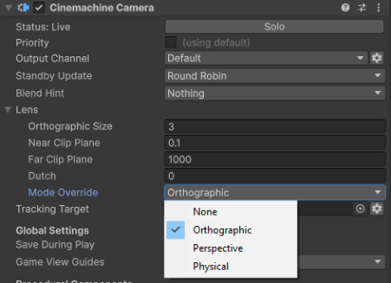

* In **Orthographic Mode** the **Orthographic Size** changes the viewport size of the camera. The larger the value, the more of the screen is in view.

* In the **Main Camera**, the **Cinemachine Brain** needs to be updated to enable **Lens Mode Override** and the **Default Mode** set to **Orthographic.**



* Set the **Tracking Target** to the object to follow (typically the player).



## Follow Camera

The **Follow Camera** is a simple camera that tracks the target object and tries to keep the target in the middle of the screen.

* On the **Cinemachine Camera**, set the **Position Control** to **Follow**.

* A Cinemachine Follow component will be added.
  + The **Follow Offset** can be adjusted to offset the camera from the target.
  + The **Position Damping** can be adjusted to change the rate at which the camera moves to the target.
    - Smaller values makes the camera more responsive.
    - Larger values makes the camera less responsive.

## Position Composer Camera

The **Position Composer Camera** is a more advance camera that allows the setting of a **Dead Zone**, **Hard Limits** and a **Lookahead**.

* On the **Cinemachine Camera**, set the **Position Control** to **Position Composer**.

* A **Cinemachine Position Composer** component will be added.

* Adjust the **Dead Zone** so the target can move freely within a defined rectangular area without triggering camera movement. Once the target exits this zone, the camera will smoothly follow to keep the target in view.

* Configure the Hard Limits to define the boundaries that the target cannot move beyond, effectively restricting the camera’s movement to a specific area.

* **Center On Activate** centers the camera on the target when the camera is activated.



* The Lookahead adjusts the offset of the camera target based on the motion of the target.
  + **Time** estimates the point where the target will be this many seconds into the future.
  + **Smoothing** smooths out the predictions to reduce jitter.
  + **Ignore Y** ignores movement on the Y axis for lookahead calculations.

## Confine Camera to Bounds

* Add a **Cinemachine Confiner 2D** component to the **Cinemachine Camera**.

* **Create Empty Game Object** (Ctrl+Shift+N) in the Hierarchy.
  + Reset the **Transform**
  + Rename it to “Bounds”

 

* Add a **Box Collider 2D** to the **Bounds** object.
  + Enable **Is Trigger** on the **Box Collider 2D** to prevent the box colliding with objects in the world.

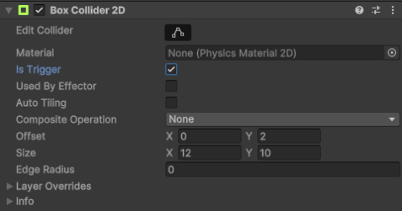

* Set the **Offset** and **Bounds** to encapsulate the area to confine the camera to.

* Drag the **Bounds** object into the **Cinemachine Confiner 2D Bounding Shape 2D** parameter.

* When the **Editor** is played, the camera will stay within the bounds of the **Bounds** **Box Collider 2D**.



